Case study on Carbohydrates, Proteins and Fats.

Name;

Professor;

Institution;

Date of Submission;

Case study on Carbohydrates, Proteins and Fats.
The first day at any new work place consistently turns out to be unique, as you save your progression in the institutional field interestingly, this time as a teacher. The main day at school consistently brings for you some very certain minutes through which you begin to discover your personality among the colleagues and the clients who now are the students. Along these lines, the primary day at work is such a day, which is recognized as an exceptionally uncommon one to describe even after quite a while. As a teacher, teaching is something we as a whole do in light of the fact that we give it a second thought and we need to move and teach the young people of today. Now and then it's tiring, yet it's absolutely awesome and enjoyable.
It on this one day, the beginning of the year that am supposed to report on my new working environment. The alarm calls and am up, prepare as usually and ready to go! I should concede, I felt a little worn out. I show up at school, make a cuppa tea, this is essential for joy I watchfully search my messages for any forthcoming gatherings or cautions, figure everything out for the day (ask the scanner works). Time to complete and check the present exercise plans, fast brew workforce conference and the class starts, the entire explanation I'm here, to instruct Ok enter the late understudies, exemplary. At the front of the classroom, taking a gander at every one of those eager countenances for the absolute first time. Present’s my opportunity to acquaint myself with my understudies, to tell them what my identity is and what they can expect throughout the year to come. I told them how excited I was to have them at a biology class.
J. Wellington Wimpy, or simply Wimpy, is the character in the long-running funny cartoon Thimble Theater and in the Popeye kid's shows dependent on it. He is a strong burger sweetheart and dear companion of Popeye's, known for his mooching ways and a misleadingly undeniable insight. He is a mild-mannered and fearful honorable man who will take the steps to get a free cheeseburger, regularly with the guarantee to readily reimburse the caring soul that gives him one come Tuesday, which he by and large won't ever do. I started the class off with the cartoon story, every student gazed at me in silence, eager and ease. I my marking scheme in my head, the scores were exceptional. I derived the topic of the day which was all about structure of carbohydrates and it components.
Case study one.
- The structure of carbohydrates.
- The carbohydrates are a gathering of normally occurring carbonyl mixtures (aldehydes or ketones) that additionally contain a few hydroxyl gatherings.
- It might likewise incorporate their subsidiaries which produce such mixtures on hydrolysis.
- They are the most bountiful natural atoms in nature and furthermore alluded to as "saccharides". The carbs which are solvent in water and sweet in taste are called as "sugars".
- Carbohydrates comprise carbon, hydrogen, and oxygen.
- The overall observational construction for starches is $Cₘ(H₂O)ₙ$ where m can be different from n.
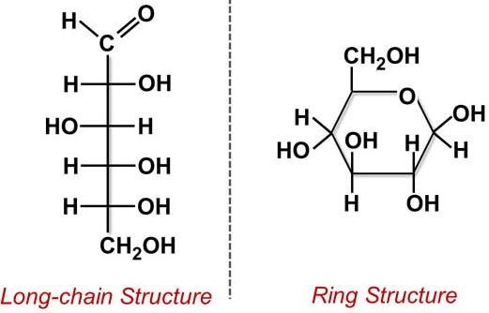
- Monomer and polymers in carbohydrates.
- Monomer of carbohydrates are Monosaccharides, Monosaccharides comprise of a carbon chain of a minimum of 3 carbon molecules containing a radical bunch joined to every carbon with the exception of 1.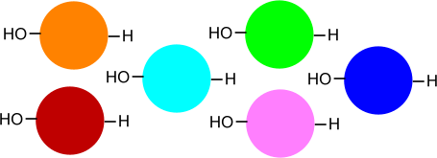
This diagram addresses various monomers.
- Polymer however (depends) disaccharide, oligosaccharide, polysaccharide.
The most widely recognized that are found in nature are cellulose, starch, dextrin and cyclodextrins, chitin and chitosan, hyaluronic corrosive, and different gums
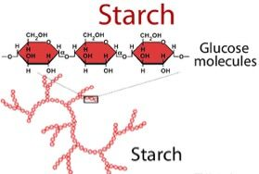
The diagram likewise addresses the polymer.

- The structure of proteins.
- Protein structure is that the three-dimensional set up of particles in Associate in nursing amino corrosive chain atom. Proteins are polymers – expressly polypeptides – formed from arrangements of amino acids, the monomers of the chemical compound. A solitary amino corrosive compound could likewise be called a buildup showing a rehashing unit of a chemical compound.
- Inside a macromolecule, several amino acids are connected along by amide bonds, during this means shaping an extended chain. Amide bonds are formed by an organic chemistry response that concentrates a water atom because it joins the amino gathering of 1 amino corrosive to the carboxyl gathering of Associate in nursing contiguous amino corrosive. The straight grouping of amino acids within a macromolecule is viewed because the essential style of the macromolecule.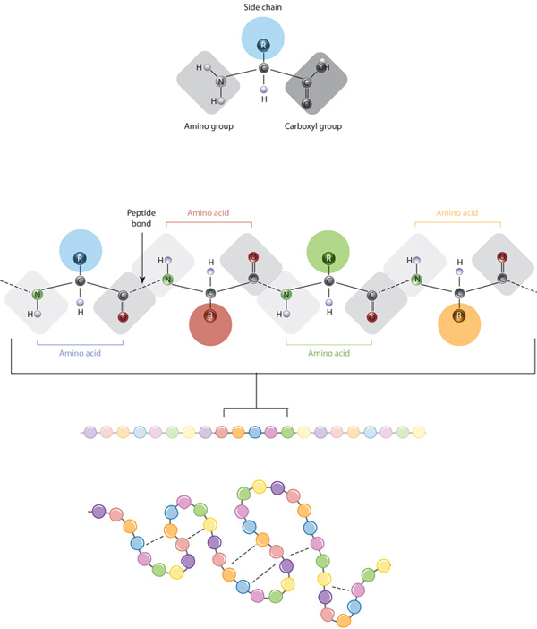
- Monomers and polymers in protein.
- A chemical compound could be a solitary particle which will be combined with different same atoms to border a chemical compound.
The structure squares of proteins are amino acids that contain parts, as an example; H, N, O, C, so some. They’re the monomers of the proteins.
- At the purpose once a whole lot or thousands of amino acids mix, they create proteins, that are then used for a few assignments in life forms, for example, endeavor job in cells, assist with polymer replication, then forth.
- Along these lines, the chemical compound are going to be the amino acids, and therefore the chemical compound are going to be merely the proteins.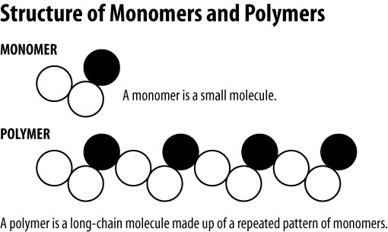
- Comparison between primary, secondary, tertiary and quaternary structures of proteins.
- The essential design of super molecule is that the progressive system's basic level and is that the specific direct arrangement of amino acids containing one peptide chain.
- Auxiliary construction may be a higher level up from the essential style and is that the normal collapsing of districts into specific primary samples of one peptide chain. Auxiliary constructions commonly control along by chemical element connections between the carbonyl gas and also the chemical bond amid chemical element.
- Tertiary construction may be a higher level up from the nonobligatory style and is that the specific three-dimensional course of action of the multitude of amino acids in a very solitary peptide chain. This style is conformational, local, and dynamic, and is control along by various non-covalent connections.
- Quaternary construction is that the insulant stage 'up' between a minimum of 2 peptide chains from the tertiary style and is that the explicit abstraction arrange and cooperation.
- The structure of fat.
- The structure squares of fat (lipid) area unit unsaturated fats and alcohol.
- Unsaturated fats found in food varieties and fats place away within the body area unit primarily gift as triacylglycerols. An alcohol atom spine to that 3 frequently distinctive, we tend to connect unsaturated fats.
- Singular non-saturated fats will be accessible at any of 3 things on the alcohol atom (named sn-1, sn-2 and sn-3). The presence of express unsaturated fats at numerous things on the alcohol particle can likewise have an effect on its qualities (for example dissolving purpose and absorbability).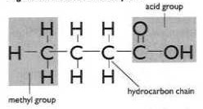
- Condensation (dehydration) and hydrolysis reaction of fats.
- Dehydration synthesis.
- Most macromolecules square measure created victimization single subunits, or building blocks, referred to as monomers. The monomers consolidate with each other utilizing valency bonds to form larger atoms referred to as polymers. In doing intrinsically, monomers discharge water atoms as side-effects. This sort of response is known as parchedness union, which signifies "to assemble while losing water."
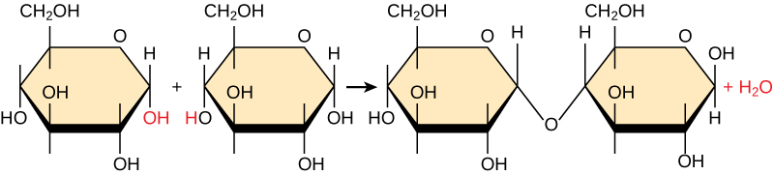
In the lack of hydration union response portrayed over, two particles of glucose are connected together to frame the disaccharide maltose. All the while, a water particle is framed.
- In the hydration the hydrogen of one monomer joins with the hydroxyl gathering of another monomer, delivering an atom of water. Simultaneously, the monomers share electrons and structure covalent bonds. As extra monomers join, this chain of rehashing monomers frames a polymer. Various sorts of monomers can join in numerous setups, bringing about a different gathering of macromolecules. Indeed, even one sort of monomer can join in an assortment of approaches to frame a few unique polymers: for instance, glucose monomers are the constituents of starch, glycogen, and cellulose.
ii. Hydrolysis.
- Polymers square measure separated into monomers in AN interaction referred to as chemical reaction, which signifies "to part water," a response wherein a water particle is utilized during the breakdown. During these responses, the polymer is broken into two segments: one section acquires a hydrogen iota (H+) and different increases a hydroxyl particle (OH–) from a split water atom.
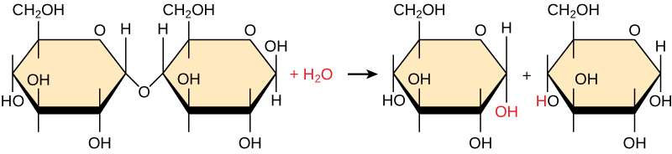
Lack of hydration and hydrolysis responses are catalyzed, or "accelerated," by explicit proteins; parchedness responses include the development of new securities, requiring energy, while hydrolysis responses break securities and delivery energy.
- Functions of carbohydrates, proteins and fats in cells of an organism.
- Carbohydrates square measure utilized for energy (glucose). Fats square measure utilized for energy once they're broken into unsaturated fats (fatty acids). Super molecule will likewise be utilized for energy, nevertheless the principal work is to help with creating chemicals, muscle, and completely different proteins. Functional group found in carbohydrates, proteins and fats.
- Among the hydrophilic sensible gatherings is that the carboxyl gathering found in amino acids, some amino corrosive aspect chains, and also the unsaturated fat heads that structure fatty oils and phospholipids.
Case study two.
- How enzymes work to speed up reaction.
Enzymes are organic impetuses. They bring down the initiation energy for responses, the lower the initiation energy for a response, the quicker the rate. In this way catalysts accelerate responses by bringing down enactment energy.

- Induced fit model of how enzymes work.
- The initiated match model could be a model for catalyst substrate affiliation. It depicts that solitary the legitimate substrate is appropriate causative the acceptable arrangement of the dynamic web site that may empower the catalyst to play out its drug work. It in addition recommends that the dynamic web site keeps on dynamic till the substrate is completely absolute to it, so, tired all the last form and charge is resolved.
- The motivated match model suggested by Daniel Koshland in 1958. It’s the lot of acknowledged model for compound substrate advanced than the lock-and-key model. Within the lock-and-key model, the affiliation of the substrate and also the compound is compared to a key (the substrate) that's deeply specific to the lock (the dynamic web site of the chemical).
- How enzymes are regulated.
- Enzymes can be managed by different atoms that either increment or decrease their movement. Particles that expansion the movement of a protein are called activators, while atoms that diminishing the action of a catalyst are called inhibitors.
- Enzyme initiation can be sped up through biochemical change of the catalyst (i.e., phosphorylation) or through low sub-atomic weight positive modulators. Similarly likewise with agonists of receptors, it is hypothetically conceivable to tie particles to chemicals to build catalysis (catalyst activators). These atoms should tie to a site other than the substrate restricting site, in any case substrate restricting can't happen.
- A compound matter is associate degree atom that ties to a chemical and diminishes its action. ... The limiting of associate degree matter will stop a substrate from coming into the chemical's dynamic website or probably frustrate the compound from catalyzing its response. Matter limiting is either reversible or irreversible.
Case study three.
- How osmosis works.
- The principle of diffusion expresses that once a permeable film isolates 2 liquid areas, water can move from area unita} of lower substance fixation to at least one of upper substance focus to accomplish balance that the diffusion pressing factors are adjusted.
- In life frameworks, the cell films allow water to diffuse across them, however they're usually tight to charged solutes (e.g., sodium, potassium) and massive natural particles (e.g., glucose). Cell films have exceptional vehicle frameworks (proteins or channels) that management the event of those particles and atoms across the cell layer.
- Little, dead particles (e.g., urea, alkali) diffuse across cell layers apace. The convergence of solutes within the compartment (particles or particles bust down within the water) decides the osmolality of the liquid, and this can be communicated as mOsm/kg of water. Within the consistent state condition, body water is spread among ICF and extracellular fluid compartments that the osmolality are a few things similar in each compartment. Consequently, the plasma osmolality could be a genuinely precise gauge of the complete body osmolality.
- Compare passive and active transport.
- Passive transport is the development of particles and atoms across the phone film without requiring energy.
- Active transport involves the development of particles across a layer from a district of lower fixation to an area of higher focus against the fixation slope, frequently helped by proteins and requires energy.
- They compare in the sense that they all involves movement of molecules and ions across a cell.
- Fluid mosaic model of cell membrane and its result to a semipermeable membrane.
- The fluid mosaic model depicts the plasma layer structure as a mosaic of phospholipids, steroid alcohol, proteins, and carbohydrates. This gives the layer (membrane) a liquid character.
- The film is specifically porous on the grounds that substances don't cross it unpredictably. A few atoms, for example, hydrocarbons and oxygen can cross the layer. Numerous huge particles (like glucose and different sugars) can't. Water can go through between the lipids.

References;
Zinn, C., Rush, A., & Johnson, R. (2018). Assessing the nutrient intake of a low-carbohydrate, high-fat (LCHF) diet: a hypothetical case study design. BMJ open, 8(2).
Burke, L. M., Whitfield, J., Heikura, I. A., Ross, M. L., Tee, N., Forbes, S. F. ... & Sharma, A. P. (2021). Adaptation to a low carbohydrate high fat diet is rapid but impairs endurance exercise metabolism and performance despite enhanced glycogen availability. The Journal of Physiology, 599(3), 771-790.
Liu, A. G., Ford, N. A., Hu, F. B., Zelman, K. M., Mozaffarian, D., & Kris-Etherton, P. M. (2017). A healthy approach to dietary fats: understanding the science and taking action to reduce consumer confusion. Nutrition journal, 16(1), 1-15.

